Family and Children’s Services of the Waterloo Region
Business Plan: 2016/2017

Introduction
This document represents the 2016/2017 Business Plan for the Family and Children’s Services of the Waterloo Region. It highlights the mandate, strategic priorities, key activities and performance indicators of the organization for the upcoming year. The plan also demonstrates how the Family and Children’s Services continues to improve our child protection services in the Region of Waterloo.

Mandate
Children’s Aid Societies are independently governed agencies that are responsible for providing mandatory and critical services, which are a safety net for the most vulnerable members of our society – infants, children and youth who are at risk of or are experiencing physical, sexual and/or emotional abuse, neglect or abandonment. CASs are mandated to intervene if a caregiver cannot adequately care for or provide for a child.
Children’s Aid Societies have been providing these services to communities in Ontario for over 100 years.
They are legislated to perform certain functions under the provisions of Section 15 of the Child and Family Services Act (CFSA). The mandate of CASs, as described in this section of the CFSA, includes the following functions:
- Investigate allegations or evidence that children who are under the age of sixteen years or are in the society’s care or under its supervision may be in need of protection;
- Protect, where necessary, children who are under the age of sixteen years or are in the society’s care or under its supervision;
- Provide guidance, counselling and other services to families for protecting children or for the prevention of circumstances requiring the protection of children;
- Provide care for children assigned or committed to its care under this Act;
- Supervise children assigned to its supervision under this Act;
- Place children for adoption under Part VII; and,
- Perform any other duties given to it by this or any other Act.
This legislation and the supporting regulations, directives and standards prescribe specific and detailed requirements for what services CASs must provide, how they must provide these services, including services to Aboriginal children and families and French language services, as well as the timelines in which these mandatory services must be provided.
Children’s Aid Societies protect and safeguard most children while they remain with their families in the community. This family-based support takes the form of intensive assessments and service plans, contacts with numerous other professionals and service providers, as well as ongoing supervision of the child while he/she remains in the family home. These are complex cases in which child protection concerns have been verified and there are risks of, or actual, abuse and neglect. As such, the work must be performed by skilled, qualified child welfare staff. Serving these children in the context of the home – when it is safe to do so – is consistent with the legislative and regulatory mandate and with the policy direction of government.

Vision, Values and Strategic Direction
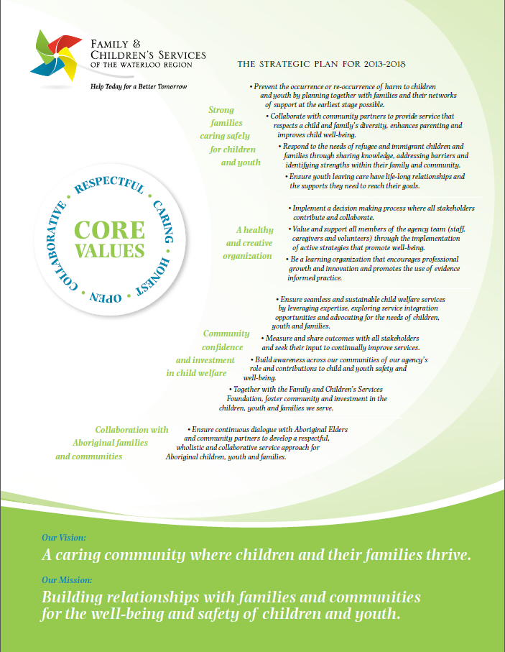

Key Activities Supporting Strategic Directions
Strategic Direction: Strong families caring safely for children and youth
Goal | Key Activities
- Prevent the occurrence or reoccurrence of harm to children and youth by planning together with families and their networks of support at the earliest possible stage | - To ensure the community is aware of the Duty to Report and the role and services of a Children’s Aid Society.  - To ensure the agency has adequate child protection resources to respond early to child protection concerns.  - To ensure our service delivery practice includes opportunities to meet with children and families and their supports to develop plans that address safety, risk and well-being.
- Collaborate with community partners to provide service that respects a child and family’s diversity, enhances parenting and improves child well-being. | - Continue our partnerships with community service agencies to provide parent support and education, recreational opportunities for children and youth, and mental health counselling  - Continue to participate in key community change initiatives such as: Moving on Mental Health, Special Needs Planning Table, Complex Needs Planning, Support for Refugees and Connectivity Table
- Respond to the needs of refugee and immigrant children and families through sharing knowledge, addressing barriers and identifying strengths within their family and community | - Increase our internal capacity to respond and engage with refugee and immigrant families in a culturally responsive way  - Continue to collaborate with community partners such as the Kitchener-Waterloo Multicultural Centre, Reception House Waterloo Region and YMCA Settlement Services to respond to the needs of refugee and immigrant families
- Ensure youth leaving care have life-long relationships and the supports they need to reach their goals | - Increase networks of supports and family connections for youth through permanency planning and family finding  - Work together with our community service providers to ensure youth have housing and other practical supports they need to transition to independence  - Improve placement stability and the percentage of youth residing in family based care

Strategic Direction: Collaboration with Indigenous families and communities
Goal | Key Activities
- Ensure continuous dialogue with Aboriginal Elders and community partners to develop a respectful, wholistic and collaborative service approach for Aboriginal children, youth and families. | - Continue our participation in the Restoration Circle with Indigenous Community leaders  - Ensure all First Nations Metis and Inuit families are offered support through Aboriginal Approach/ODR (Original Dispute Resolution), a process that is led indigenous professionals and draws upon traditional ways of healing, decision making and resolving conflict

Strategic Direction: Community confidence and investment in child welfare.
Goal | Key Activities
- Ensure seamless and sustainable child welfare services by leveraging signature events, exploring service integration opportunities and advocating for the needs of children, youth and families. | - Actively participate in provincial and local initiatives that support the Provincial Call to Action agenda
- Measure and share outcomes with all stakeholders and seek their input to continually improve services. | - Continue to support the work of the provincial performance indicator project  - Share our local data on five key performance indicators that measure critical child welfare outcomes in the areas of safety, permanence and well-being  - Monitor and implement strategies in our Quality Improvement Plan to improve compliance  - Continue to assess and implement learnings from Ministerial reviews and reports, including: Crown Ward Reviews, Serious Occurrences, PACY and Quarterly Ministry Service and Financial Data Reporting  - Continue to gather and learn from data and feedback from the children, youth and families we serve
- Build awareness across our communities of our agency’s contributions to child and youth safety and well-being. | - Continue to engage with our community and local service partners on the role of a Children’s Aid Society  - Leverage our Foundation’s signature events as opportunities to increase public awareness
- Together with the Family and Children’s Services Foundation, foster community commitment and investment in the children, youth and families we serve. | - Continue to maximize the strategic alignment between the Foundation and Agency  - Support a strong governance process for the Agency and Foundation Boards  - Continue to implement key areas of focus and the multi-year development plan for the Foundation  - Continue to strengthen and build relationships with existing and potential donors

Strategic Direction: A healthy and creative organization
Goal | Key Activities
- Value and support all members of the agency team (staff, caregivers and volunteers) through the implementation of active strategies that promote well-being. | - Recognize the role and impact of all members of the agency team  - Continue to support an Employee and Family Assistance Program to encourage self-care  - Enhance worker safety policies and support practices that maximize staff safety
- Be a learning organization that encourages professional growth and innovation and promotes the use of evidence informed practice | - Continue the use of the emergent learning model in promoting ongoing learning and evaluation  - Support the work of the Evidence Informed Innovation Committee in assessing and evaluating service initiatives

Performance Measurement
Children’s Aid Societies understand the importance of measuring performance and outcomes for children and their families. To this end we have developed key Performance Indicators (PIs) that best outline effectiveness in delivering the child protection mandate.
There are currently five PIs that are reported:
- Recurrence of Child Protection Concerns in a Family after an Investigation
- Recurrence of Child Protection Concerns in a Family after Ongoing Services were Provided
- Days of care by placement type
- Time to permanency
- Quality of the caregiver-youth relationship
Each of these Performance Indicators is described in more detail below.
Local data for each of the five performance indicators, can be viewed at: www.facswaterloo.org/aboutus/child-welfare-data-and-results

Safety Outcome - Recurrence of Child Protection Concerns in a Family after an Investigation
This PI measures the percentage of family cases closed at investigation in a fiscal year that were re-investigated within 12 months after closing and where the child protection concerns were verified.
This measure is important because closing a case following an investigation assessment suggests that there are no child protection concerns requiring ongoing Children’s Aid Society involvement. However, at the conclusion of many investigations, workers make referrals to community-based services for families. This measure is important for further understanding of those families that return to a Children’s Aid Society with verified protection concerns and those that do not, both in terms of the nature and intensity of the services offered, and the risks, strengths and needs of children and families. Increasing knowledge in these areas will inform decision-making and improve service delivery.
There is no agreed-upon benchmark for the “acceptable” level of recurrence. While a lower level is generally desirable, the rate of recurrence is unlikely ever to be 0% for a variety of reasons, including the chronic nature of many of the struggles experienced by families commonly known to the child welfare system, e.g., poverty, substance abuse and mental health problems. Furthermore, the reconnection of some families with the child welfare system can be in and of itself a protective factor to children whose families are connected with necessary supports.

Safety Outcome - Recurrence of Child Protection Concerns in a Family after Ongoing Protection Services Were Provided
This PI measures the percentage of family cases closed at ongoing protection in a fiscal year that were re-investigated within 12 months after closing where the child protection concerns were verified.
This measure is important because closing a case following ongoing services suggests that child protection concerns have been addressed and no longer require ongoing Children’s Aid Society involvement. However, at the conclusion of Children’s Aid involvement, many families continue to receive supportive services from other agencies in the community. This indicator measures the extent to which services have been successful in reducing risk to children over the 12 month period following Children’s Aid Society involvement. This measure is important for further understanding of those families that return to a Children’s Aid Society with verified protection concerns and those that do not, both in terms of the nature and intensity of the services offered, and the risks, strengths and needs of children and families. Increasing knowledge in these areas supports improvements in decision-making and service delivery.
There is no agreed-upon benchmark for the “acceptable” level of recurrence. While a lower level is generally desirable, the rate of recurrence is unlikely ever to be 0% for a variety of reasons, including the chronic nature of many of the struggles experienced by families commonly known to the child welfare system, e.g., poverty, substance abuse and mental health problems. Furthermore, the reconnection of some families with the child welfare system can be in and of itself a protective factor to children whose families are connected with necessary supports.

Permanency Outcome – Days of Care, by Placement Type
This PI measures, for all children admitted to the care of a Children’s Aid Society, the days of care provided in the fiscal year, by placement type.
We know that children placed in family-based care are more likely to achieve permanency when the exit care, i.e., be discharged to parents or family including adoptive families or legal custody arrangements, compared to children in group care. Family-based care is the preferred placement setting for the majority of children in care. Children placed in family settings have greater opportunities to form a connection with consistent caregivers and to experience the benefits associated with membership in a family.
While a high rate of family-based care is desirable, selection of a placement setting should be first and foremost influenced by the needs of the child and the fit to the placement. Given the mandate of a Children’s Aid Society, and the nature of the challenges experienced by some children and youth, it is likely that there will always be some young people in care who require specialized treatment, programs and structure associated with group care settings.

Permanency Outcome – Time to Permanency
This PI measures, for all children admitted to the care of a CAS during the fiscal year, the cumulative percentage discharged within a specific time period (i.e. 12 months, 24 months and 36 months since admission).
One of the mission-critical outcomes in child welfare is to facilitate permanent living arrangements for all children that are safe, stable and supportive of lifetime relationships. The child welfare system in Ontario has multiple options through which permanency can be achieved (e.g., reunification with parents, legal custody, and adoption). Permanency planning is a significant focus for children in care, whose permanency status, both legally and psychologically, is uncertain. The timing and nature of permanency may look different for every child depending on the child’s needs, family circumstances, court processes, and availability of community service providers.
A key factor that influences time to permanency is child age at admission. Children who enter care at a young age are more likely to be discharged to certain types of permanency (e.g., adoption) compared to older children. Young children often achieve permanency within shorter timeframes, supported by legislation that limits the allowable cumulative time in short-term care for children under 6 years of age compared to older children. An additional factor that impacts time to permanency is the needs of the child, with more complex needs associated with longer timeframes to achieving permanency.

Well-being Outcome - Quality of the Caregiver and Youth Relationship
This PI measures the average score for children in care (aged 10-17) from a standard scale that measures a young person’s perception of the quality of the relationship with his or her primary caregiver. The scale measures the following four items:
- How well do you feel he/she understands you?
- How much fairness do you receive from him/her?
- How much affection do you receive from him/her?
- Overall, how would you describe your relationship with him/her?
Each of these four items is rated from 0 to 2, yielding a composite score with a minimum of 0 and a maximum of 8.
This indicator is important because the quality of the caregiver-youth relationship is at the heart of service to children in care. Research demonstrates that a young person’s perception of the quality of his/her relationship with his/her caregiver predicts the following: current happiness; self-esteem; positive behaviour; and placement satisfaction. As scores increase on the quality of the caregiver relationship scale, so do positive outcomes across each of these areas (e.g. higher self-esteem).
The key influencing factor is the young person’s perception that the caregiver understands, treats fairly, shows affection towards, and has a close relationship with him/her.

Contact Information
Family and Children’s Services of the Waterloo Region
200 Ardelt Avenue,
Kitchener, ON N2C 2L9
519-576-0540

Child and Family Services Act

